**D1 – Explore how web pages using scripts are implemented in different browsers**

**Introduction**

In this report, I will explain how web pages is different between the two different websites.

**Internet Explorer**

[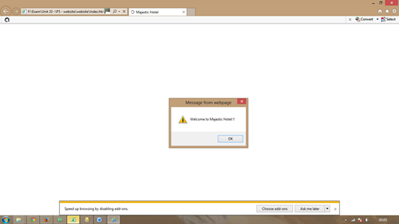](http://www.google.co.uk/url?sa=i&rct=j&q=&esrc=s&source=images&cd=&cad=rja&uact=8&ved=0CAcQjRxqFQoTCKPU5sSUlMYCFWeN2wod5wUAWQ&url=http://bteclevel3itdiploma.blogspot.com/p/unit-20-d2-xplore-how-web-pages-using.html&ei=Pg-AVaO9F-ea7gbni4DIBQ&bvm=bv.96041959,d.ZGU&psig=AFQjCNExX_1DUBxPO0hduTmgBLD9IQYIRg&ust=1434542264410227)[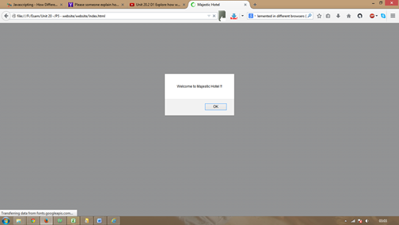](http://1.bp.blogspot.com/-fc8R9eqVY9E/U7qG4CAmJYI/AAAAAAAAAH4/3w11oPRrONs/s1600/2.png)

**Internet Explorer**

**function thisBrowserIs(browserTest){**  
**if(navigator.userAgent.indexOf(browserTest)!=-1){**  
**return true;**  
**}**  
**}**

}

Read more : <http://www.ehow.com/how_7398289_use-implemented-two-different-browsers.html>

**Google Chrome**

**Browser Detection**

Browser detection is a set of techniques that is used on different browsers. In this case, as you can see the screenshots above, it shows the difference. Below are the difference between the two.

**Difference between the two**

**Similarities**

* Both of the layout is the same
* Everything is in place. As in the message that is in place is what is said.

**Difference**

* The colour of the background is different
* The place of is different. Google has it right in the centre and Internet Explorer is at the top.
* They are both different due to both of them being programmed differently
* At the bottom, a message appears up whereas Google Chrome does not give another message.

[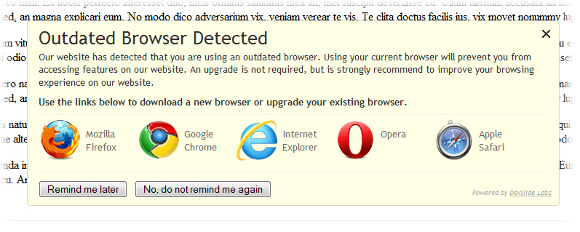](http://www.google.co.uk/url?sa=i&rct=j&q=&esrc=s&source=images&cd=&cad=rja&uact=8&ved=0CAcQjRxqFQoTCI2Ct8OVlMYCFcNu2wodKEwAnw&url=http://www.devslide.com/labs/browser-detection&ei=RxCAVc3COcPd7QaomIH4CQ&bvm=bv.96041959,d.ZGU&psig=AFQjCNFcFxvA2XpB5rrYeHvYTsjCNJhMuQ&ust=1434542534634213)

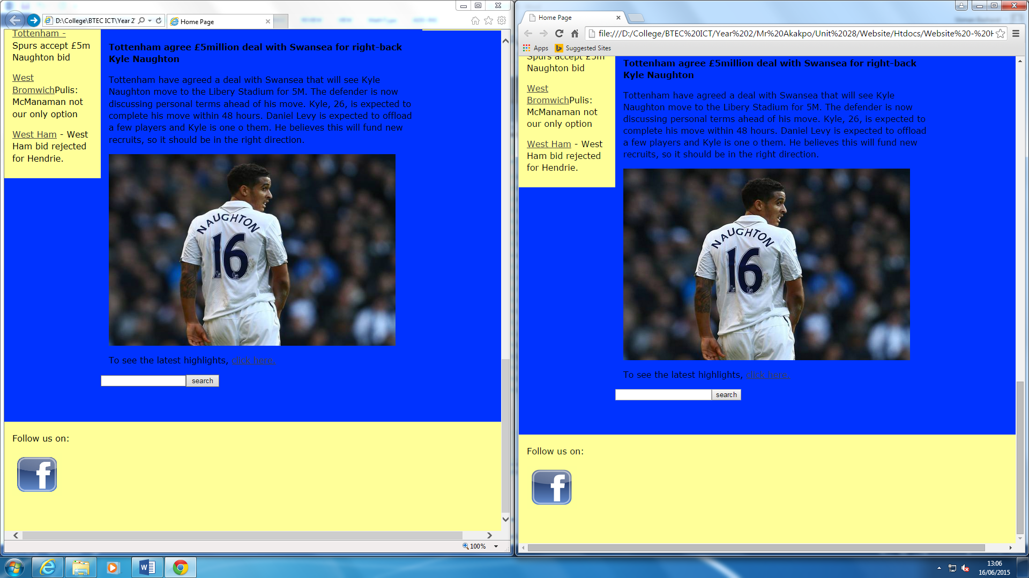**Search Bar used in my own website**